YEAR 12 CHEMISTRY SAMPLE TEST

OXIDATION AND REDUCTION: NAME:

Answer all questions

Part A: Multiple Choice Questions. (10 marks)

1. In which one of the following compounds is the oxidation number of the nitrogen atom highest?

A. NF₃
B. HNO₃
C. NO
D. NH₂NH₂

2. A drop of bromine is added to a potassium iodide solution. We would expect:

I iodine to precipitate
II iodide ions to gain electrons
III potassium bromide to form
IV bromine to be reduced.

A. I and III only
B. III and IV only
C. I and IV only
D. I, III, and IV only

3. Select the reaction in which oxidation and reduction processes occur
A. Ca(OH)_{2(aq)} + CO_{2(g)} CaCO_{3(s)} + H₂O_{(l)}
B. Cu ²⁺_{(aq)} + 4 I⁻_{(aq)} 2CuI_{(s)} + I_{2(s)}
C. Cr₂O₇²⁻_{(aq)} + 2OH⁻_{(aq)} 2CrO₄²⁻ _{(aq)} + H₂O_{(l)}
D. Cu(OH)_{2(s)} + 2NH_{3(aq)} + 2NH₄⁺_{(aq)} [Cu(NH₃)₄]²⁺_{(aq)} + 2H₂O_{(l)}

4. In the reaction

IO₃⁻ + 5I⁻ + 6H⁺ 3I₂ + 3H₂O

A. I⁻ is reduced and IO₃⁻ is oxidised
B. H⁺ is reduced and IO₃⁻ is oxidised
C. IO₃⁻ is reduced and I⁻ is oxidised
D. H⁺ is reduced and I⁻ is oxidised

5. In which one of the following sets of substances are all members of the set able to undergo a spontaneous redox reaction with pure water?

A. Fe, Co²⁺, Cl₂
B. H⁺, Na⁺, Br₂
C. K, F₂, Ag⁺.
D. F₂, Mg, Au³⁺

6. Consider the following half cells which are set up under standard conditions.
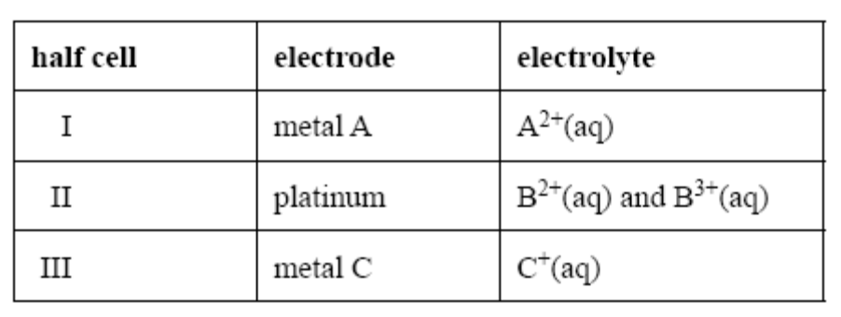
- When a galvanic cell is constructed from half cell I and half cell II, the electrode in half cell II is negative.
- When a galvanic cell is constructed from half cell II and half cell III, the electrode in half cell III is negative.

The strongest oxidant is

A. A²⁺_{(aq)}
B. B²⁺_{(aq)}
C. B³⁺_{(aq)}
D. C⁺_{(aq)}

7. A fuel cell currently under development for powering small electronic devices is based on the reaction of methanol and oxygen using an acidic electrolyte.

The reductant in the cell reaction and the half reaction at the anode are

reductant anode reaction

A. methanol O_{2(g)} + 4H⁺_{(aq)} + 4e⁻ → 2H₂O_{(l)}

B. oxygen O_{2(g)} + 4H⁺_{(aq)} + 4e⁻ → 2H₂O_{(l)}

C. methanol CH₃OH_{(g)} + H₂O_{(l)} → CO_{2(g)} + 6H⁺_{(aq)} + 6e⁻

D. oxygen CH₃OH_{(g)} + H₂O_{(l)} → CO_{2(g)} + 6H⁺_{(aq)} + 6e⁻

8. Diagram A shows a dry cell. Diagram B shows a lead-acid cell.

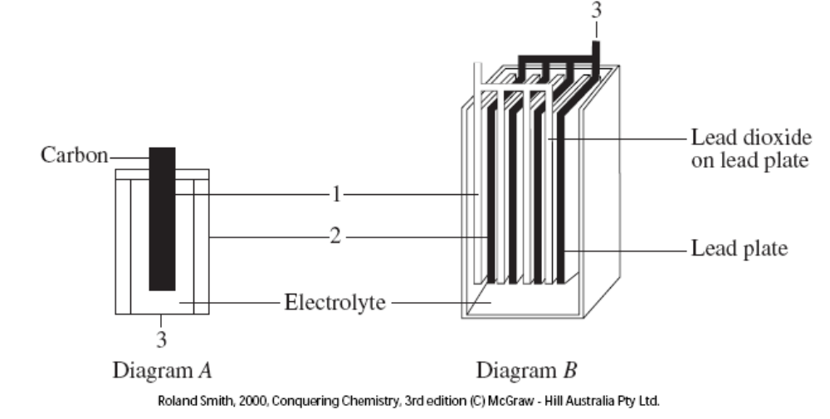
Which of the following shows the correctly labelled parts?
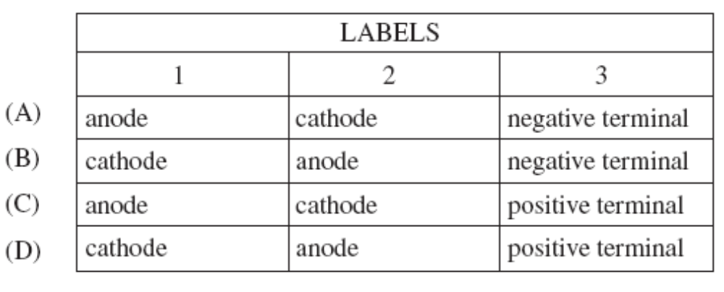
9. An electrochemical cell is set up as shown in the diagram
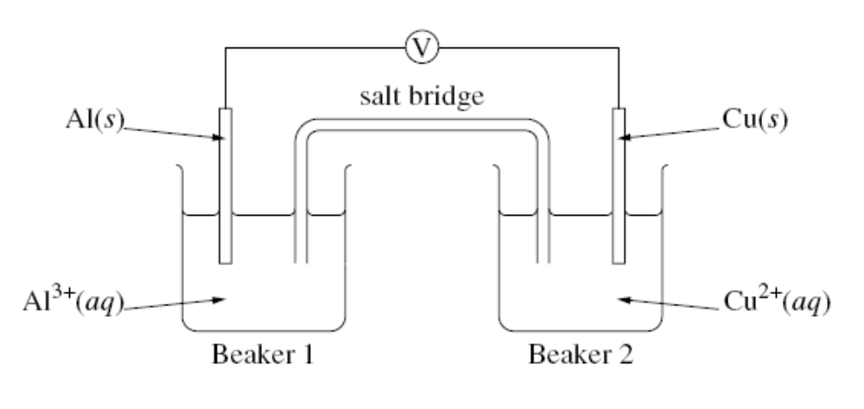

What are two observations for this electrochemical cell?

 | Observation 1 | Observation 2
A. | In Beaker 2 the blue solution faded | A reddish precipitate formed on the copper electrode
B. | A reading was shown on the voltmeter | In Beaker 2 the solution became a darker blue
C. | A grey precipitate formed on the aluminium electrode | In Beaker 2 the solution became a darker blue
D. | In Beaker 2 the solution became a darker blue | The copper electrode dissolved

10. Magnesium is often attached to iron pipelines, especially when they pass through salty swampy areas. The magnesium stops the iron corroding. Which of the following best describes the mechanism by which the magnesium protects the iron?

A. The magnesium reacts with the rust on the pipe and electrons are transferred from magnesium to the iron oxide. Magnesium oxide is formed and iron oxide is reduced back to iron, thereby eliminating corrosion.

B. The magnesium reacts by transferring electrons to all the hydrogen ions in the immediate region of the pipeline and so stops the acid corroding the pipe.

C. The magnesium forms a protective coating over the iron which keeps out the salty water and prevents corrosion.

D. The magnesium reacts so that electrons flow directly from magnesium to iron. The iron is thus prevented from corroding because the release of iron ions into solution is effectively stopped?

END OF SECTION ONE
SECTION TWO: SHORT ANSWER QUESTIONS (15 marks)

11. The following diagram represents a H⁺_{(aq)}/H_{2(g)} half cell for the reaction

2H⁺_{(aq)} + 2e⁻ → H_{2(g)}
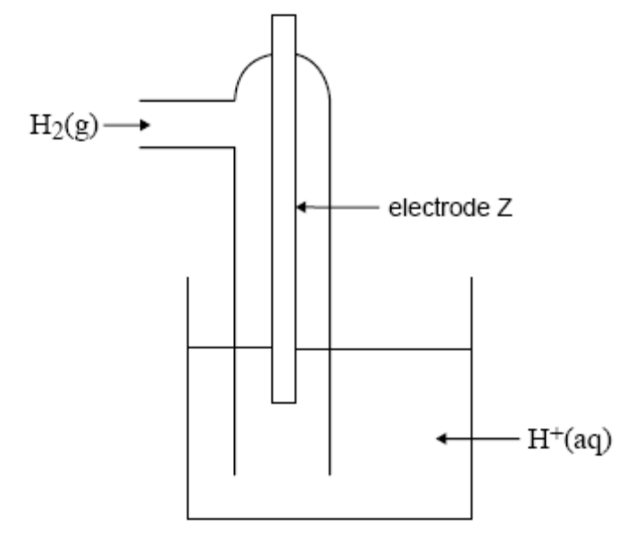
A. i. For this half cell, identify an appropriate material for electrode Z.

ii. For this half cell to be a standard half cell;

- state the temperature at which it must operate
- and the required pH of the solution of H⁺_{(aq)} ions
(3 marks)
B. A galvanic cell consists of the following half cells which have been set up under standard conditions.

Half cell 1: the H⁺_{(aq)}/H_{2(g)} half cell described in part a.
Half cell 2: a cadmium (Cd) electrode in a solution containing Cd²⁺_{(aq)}

After some time, the pH in half cell 1 has increased. Use this information to identify the species in this galvanic cell which is the stronger reductant and explain how you reached this conclusion.

The stronger reductant is

Explanation

(3 marks)

12. The diagram shows a simple experiment done as part of the junior science
course in many high schools.
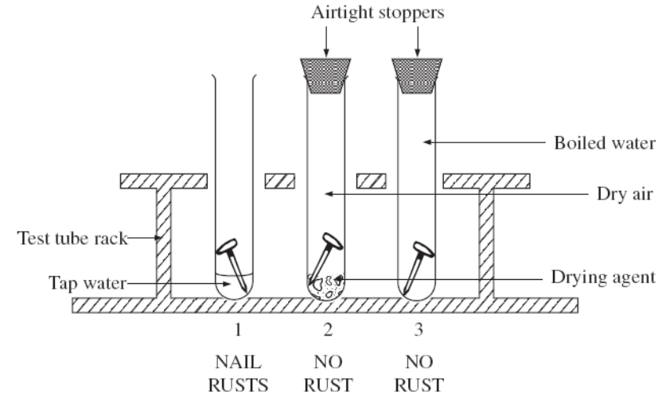

A. From this experiment, what would you conclude is necessary for iron to rust?

B. Rust is a complex mixture of compounds (Fe₂O₃.xH₂O) that forms when iron corrodes.
Write the half-equations and overall equation for the corrosion of iron.

Ox ½ equation

Red ½ equation

Overall equation

C. Adding salt to test tube 1 would accelerate the rusting process. Explain.

D. Cathodic protection is another method to prevent iron from rusting. Explain how this principle works.

E. Prevention of metal corrosion is costly, but necessary if the maximum life of metals used for machinery, building and so on is to be obtained.

Makers of garden tools sometimes recommend that the steel parts be sprayed regularly with a thin lubricating oil. Explain how this helps prevent corrosion of the steel.

F. Metal corrosion often starts in the places where the metal has been bent or suffered stress. Explain.

G. In which of the situations below would the nails corrode before the roof?

- A zinc roof with iron nails
- An iron roof with copper nails
- A copper roof with iron nails.

9 marks
SECTION THREE: EXTENDED ANSWER QUESTIONS (15 marks)

Q13. An experiment was carried out in which the relationship between the difference in reactivity of two metals, chromium and tin and the voltage of the cell that may be constructed from them.

A. State which metal was the cathode and which was the anode.

Metal 1: anode or cathode:

Metal 2: anode or cathode
1 mark
B. Draw the working cell that you constructed and label it fully.
On your cell, show the flow of ions and the flow of electrons.

2 marks
C. For your cell:

write the overall equation for the reaction;

1 mark
calculate the standard potential for your reaction.

1 mark
14. The percentage purity of a sample of manganese (IV) oxide, MnO₂, can be found by treatment with an excess of a standard sodium oxalate solution in the presence of dilute sulfuric acid.

The Mn⁴⁺ ions are reduced to Mn²⁺ and the oxalate ions [C₂O₄²⁻] are oxidized to carbon dioxide gas in this reaction. After the reaction is complete, the excess sodium oxalate is titrated with a standardized potassium permanganate solution. One such impure sample of manganese(IV) oxide of mass 1.325 g was reacted with 150.0 mL of acidified 0.0965 mol L⁻¹ sodium oxalate.

The mixture was boiled gently to dissolve the solid. After cooling, the solution was titrated with 0.0125 mol L⁻¹ potassium permanganate solution. The volume of the potassium permanganate solution required was 21.57 mL. Calculate the percentage purity of the manganese (IV) oxide sample.
10 marks

END OF TEST
UNIT3BCHE SOLUTIONS

OXIDATION AND REDUCTION SAMPLE TEST: Answer all questions

Section One: MULTIPLE CHOICE QUESTIONS (10 marks)

1B | 2D | 3B | 4C | 5D | 6A | 7C | 8B | 9A | 10D

Section Two: Short Answer Questions (15 marks)

11.
A. i Platinum
ii 25 ⁰C
iii [H⁺] = 1 molL⁻¹ = 10⁰ therefore a pH = 0

B. Cd is a stronger reductant than H₂
The pH rises as the H⁺_{(aq)} ions are consumed
Cd_{(s)} Cd²⁺_{(aq)} + 2e⁻ E⁰ = + 0.40 V
2H⁺_{(aq)} + 2e⁻ H_{2(g)}

12.
A. Both O₂ and H₂O are required for corrosion.

B. Fe → Fe²⁺_{(aq)} + 2e⁻ E⁰ = + 0.44 V
O₂ + 2H₂O + 4 e⁻ → 4OH⁻_{(aq)} E⁰ = + 0.40 V
2 Fe_{(s)} + O_{2(g)} + 2H₂O_{(l)} → 2Fe²⁺_{(aq)} + 4OH⁻_{(aq)} E⁰ = + 0.84 V

C. Salt solution is an electrolyte, it increases the conductivity (movement of ions)

D. Corrosion (rusting) is an anodic process. If iron is made the cathode, reduction will take place here (not oxidation). This can be done by attaching the iron to the negative terminal of an external power supply and applying a voltage > 0.84 V.

E. Corrosion is an electrochemical (galvanic) process. For corrosion of iron to take place, there needs to be O₂ and H₂O. Lubricating oil acts as a barrier protection, preventing O₂ and H₂O from coming into contact with the iron.

F. The metallic crystal lattice has been distorted in these regions under stress. The Fe²⁺ ions in the “sea” of delocalised electrons in this region are not as tightly bound ans so it is easier for the Fe²⁺ ions to leave the lattice, i.e. undergo oxidation.

G. A copper roof with iron nails, the nails act as an anode and the Fe undergoes oxidation and the electrons move onto the copper where reduction takes place.

Section Three: Extended Answer Questions (15 marks)

13.
A. Chromium (anode)
Tin (cathode)

B.
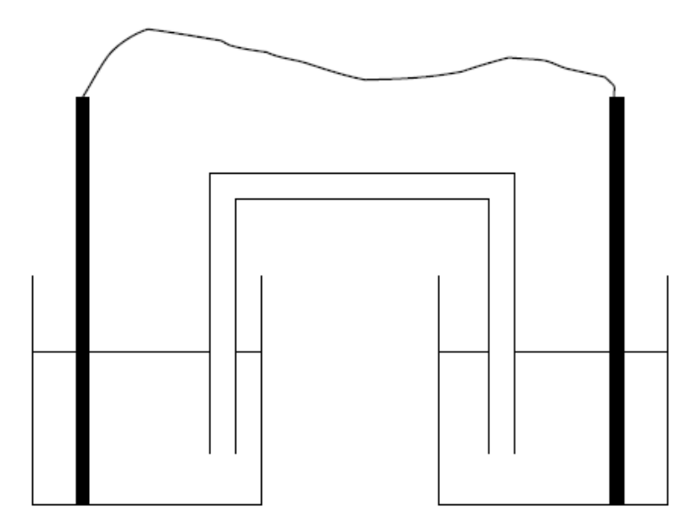
C. Cr_{(s)} Cr³⁺_{(aq)} + 3e⁻ E⁰ = +0.74 V x 2
Sn²⁺_{(aq)} + 2e⁻ Sn E⁰ = −0.14 V x 3
2Cr_{(s)} + 3Sn²⁺_{(aq)} 2Cr³⁺_{(aq)} + 3Sn_{(s)}

E⁰ = + 0.74 + (−0.14) = + 0.60 V

14.
The reaction is: Mn⁴⁺(aq) + 2e⁻ → Mn²⁺(aq)
C₂O₄²⁻(aq) → 2CO₂(g) + 2e⁻
add: Mn⁴⁺(aq) + C₂O₄²⁻(aq) → Mn²⁺(aq) + 2CO₂(g)
n(C₂O₄²⁻)_{total} = c.V. = (0.0965 mol L⁻¹)(0.150 L) = 0.014475 mol.

The excess moles of oxalate were reacted with standardised permanganate solution:

2MnO₄- + 16H⁺ + 10e⁻ → 2Mn²⁺ + 8H₂O
5C₂O₄²⁻ → 10CO₂ + 10e⁻
2MnO₄⁻ + 5C₂O₄²⁻ + 16H⁺ → 2Mn²⁺ + 10CO₂ + 8H₂O

n(C₂O₄²⁻)_{excess} = 5/2 n(MnO₄⁻) = 5/2(c.V) = 5/2(0.0125 mol L⁻¹)(0.02157 L)
= 6.741 x 10⁻⁴ mol.
Hence, the moles of oxalate which reacted with the Mn⁴⁺ as in the first equation above:
= (total moles - excess moles) = (0.014475 mol - 0.0006741 mol) = 0.01380 mol.
Hence, n(MnO₂) = 0.01380 mol
m(MnO₂) = n.M = (0.01380 mol)(86.94 g mol⁻¹) = 1.1998 g.
Hence, % purity = (m(MnO₂)) / (m(sample)) x 100
= [(1.1998 g) / (1.325 g)] x 100 = 90.55%
Answer: The sample is 90.6% by mass manganese(IV) oxide.

